SESSION 10

SUBJECT: FORMAL TECHNICAL REVIEW (FTR) & STATIC TESTING

Question 1: Download a sample SRS (Software Requirements Specification) document for a food delivery app (like Zomato) and perform a peer review by highlighting at least 5 unclear or ambiguous requirements.
Answer:

1. Introduction
A Software Requirements Specification (SRS) is a document that describes the functional and non-functional requirements of a software application. It explains what the system should do, how it should behave, and what conditions it must satisfy.
For this peer review, I selected a sample SRS document for an Online Food Delivery System.
Reference SRS document:
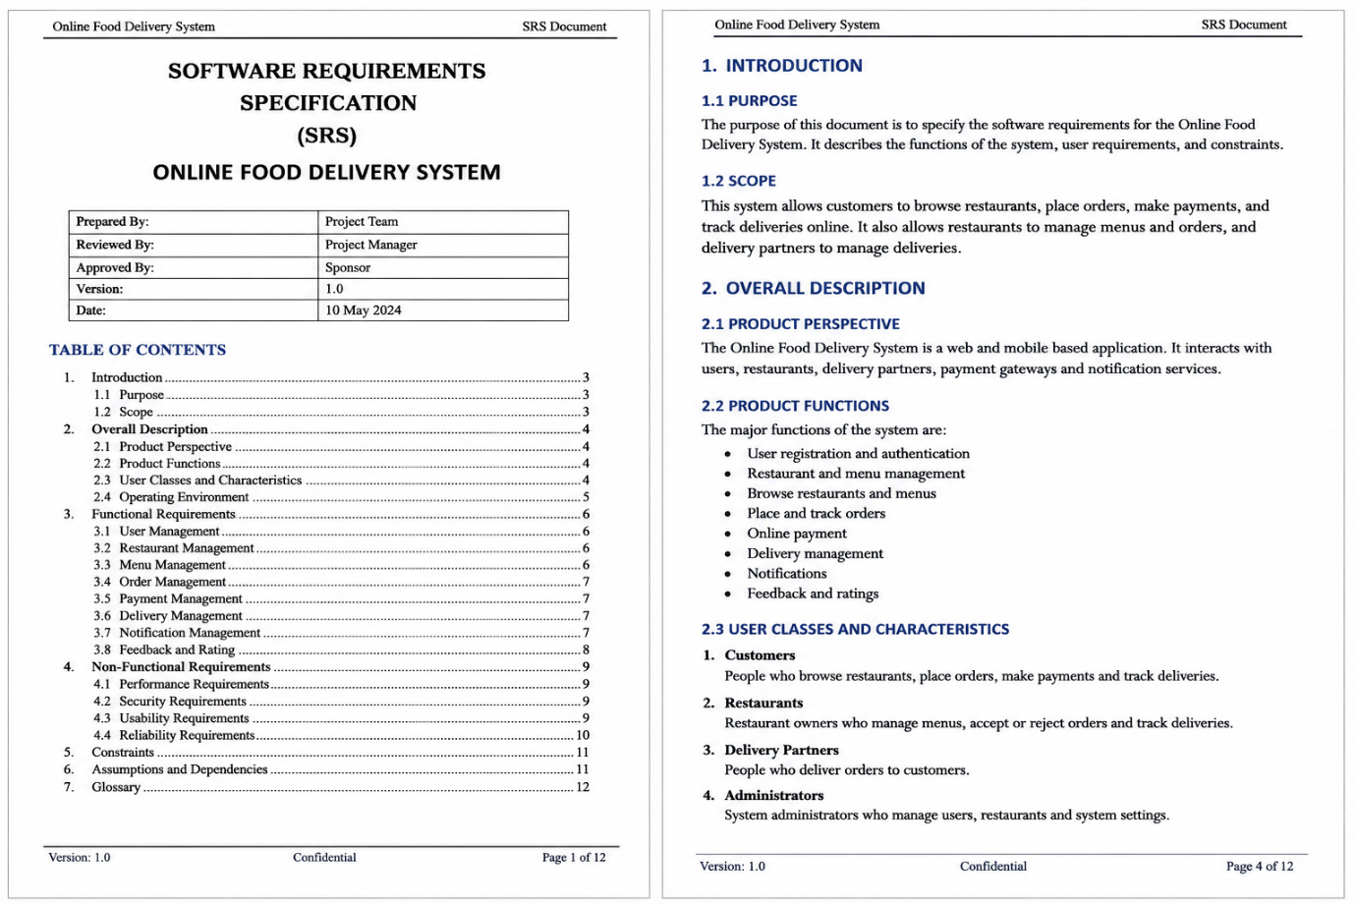
The document describes features such as user management, menu management, order processing, payment services, notifications, delivery optimization, and feedback.

2. Objective of the Peer Review
The objective of this review is to identify unclear, ambiguous, incomplete, or difficult-to-test requirements in the SRS. Clear requirements help developers understand the expected functionality and allow testers to prepare accurate test cases.

3. Unclear or Ambiguous Requirements Identified
No. | Requirement or statement reviewed | Problem identified | Suggested improvement
1 | The system shall provide a user-friendly interface. | The term "user-friendly" is subjective. Different users may have different opinions about what is user-friendly. | Define usability criteria, such as successful completion of key tasks by at least 90% of representative test users.
2 | The system shall provide fast restaurant search results. | The word "fast" does not specify an acceptable response time or testing conditions. | Specify that restaurant search results must appear within 2 seconds for 95% of requests under a defined load and network condition.
3 | The system shall deliver orders on time. | The expected delivery time, permitted delay, and method of calculating delivery time are not clearly defined. | Specify that an order must be delivered within the estimated delivery window displayed at checkout, subject to defined exceptions.
4 | The system shall send notifications for important order updates. | The term "important order updates" does not identify which events require notifications or how quickly they must be sent. | List the events, such as order confirmation, restaurant acceptance, dispatch, and delivery, and define the delivery-time target for each notification.
5 | The system shall automatically assign nearby delivery partners. | The terms "nearby" and "automatically assign" do not define distance limits, selection rules, or what happens if no delivery partner is available. | Define the maximum eligible distance, assignment priority, workload rules, and fallback behavior when no eligible delivery partner is available.
6 | The system shall display real-time order tracking. | The required refresh interval and acceptable location accuracy are not fully clear from this statement alone. | Specify the tracking update interval, acceptable location accuracy, and behavior when GPS or internet connectivity is unavailable.

4. Impact of These Ambiguities
These unclear requirements can create several problems:
- Developers may implement different interpretations of the same requirement.
- Testers may not know the exact expected results.
- Customers may receive inconsistent service.
- Defects may be discovered late in development.
- Project costs and delivery time may increase because requirements need clarification and rework.

5. Peer Review Recommendations
- Use clear, specific, and measurable language.
- Avoid subjective terms such as "fast," "easy," and "user-friendly" unless they are defined.
- Assign a unique identification number to each requirement.
- Define expected results and error-handling behavior.
- Review the revised requirements with the business analyst, developer, tester, and relevant stakeholders.

Conclusion: The peer review identified six requirements that need clarification or more precise acceptance criteria. Improving these requirements will make the SRS easier to understand, implement, and test, reducing the possibility of misunderstandings and defects.

Question 2: Conduct an informal review of a friend's written test case set for a simple login feature (username and password), and write down 3 suggestions or improvements you would make.
Answer:

1. Introduction
An informal review is a simple review in which a tester examines a document or test case set without following a formal review process. The purpose is to identify missing test conditions, unclear steps, and possible improvements.
For this activity, I reviewed a sample test case set for a login feature that requires a username and password.

2. Sample Test Case Set Reviewed
Test Case ID | Test Scenario | Steps | Expected Result
TC_LOGIN_01 | Login with valid credentials | Enter a username and password and click Login. | The user should log in successfully.
TC_LOGIN_02 | Login with invalid credentials | Enter an incorrect username and password and click Login. | An error message should be displayed.
TC_LOGIN_03 | Login with empty fields | Leave the username and password empty and click Login. | The system should validate the fields.

3. Three Suggestions or Improvements
Suggestion 1: Add Positive and Negative Test Cases
The test case set contains only a few basic scenarios. It should also cover situations where only one credential is incorrect.
Improvement:
Add separate test cases for:
- Valid username and valid password.
- Invalid username and valid password.
- Valid username and invalid password.
- Empty username.
- Empty password.
- Both fields empty.
This will provide better coverage of the login functionality.
Suggestion 2: Make the Test Steps and Expected Results More Specific
The current expected results, such as "an error message should be displayed," are too general. The tester should know exactly what behaviour to verify.
Improvement:
Specify that:
- Valid credentials should open the authenticated home page.
- Invalid credentials should prevent login and display an appropriate error message.
- Empty required fields should trigger validation messages.
- The password should be masked while being entered.
Specific expected results make it easier to decide whether a test has passed or failed.
Suggestion 3: Include Test Data and Preconditions
The test cases do not identify the test account or the conditions required before execution.
Improvement:
Add the following details:
- Precondition: The application is available, and the test account is registered and active.
- Test Data: A valid username, valid password, and separate invalid values.
- Test Case ID: A unique ID for every test case.
- Actual Result: A column to record the observed result during execution.
- Status: A column to mark the test as Pass or Fail.

4. Example of an Improved Test Case
Field | Details
Test Case ID | TC_LOGIN_004
Test Scenario | Login with a valid username and password
Precondition | The user has an active registered account.
Test Data | Username: testuser01; Password: ValidTest@123
Steps | 1. Open the login page. 2. Enter the valid username. 3. Enter the valid password. 4. Click Login.
Expected Result | The system authenticates the user and redirects them to the home page.
Actual Result | To be filled during execution.
Status | To be filled after execution.

Conclusion: The three main improvements are to increase test coverage, make test steps and expected results specific, and include test data and preconditions. These changes will make the login test cases more complete, understandable, and useful during manual testing.

Question 3: Simulate a walkthrough session by explaining the steps of a test case for 'Add to Cart' functionality (like Flipkart) to a classmate and note any questions or feedback they give you. Hint: Focus on whether all steps are clear and if any preconditions or expected results are missing.
Answer:

1. Introduction
A walkthrough is a review technique in which the author explains a document, test case, or process to other participants. The participants ask questions, identify missing information, and suggest improvements.
For this activity, I simulated a walkthrough session for the Add to Cart feature of a Flipkart-like shopping application.

2. Test Case Details
Field | Description
Test Case ID | TC_CART_001
Test Scenario | Verify that a user can add an available product to the shopping cart.
Preconditions | The application is available, the user can access the product catalogue, and the selected product is in stock.
Test Data | Product: Wireless Mouse; Quantity: 1
Expected Result | The product is added to the cart, the cart count increases by one, and the product details and price are displayed correctly.

3. Steps Explained During the Walkthrough
- Open the Flipkart-like application.
- Log in with valid user credentials if login is required.
- Search for "Wireless Mouse."
- Select an available wireless mouse from the search results.
- Verify the product name, price, and availability.
- Click the "Add to Cart" button.
- Open the shopping cart.
- Verify that the selected product appears in the cart.
- Verify that the product quantity is one.
- Verify that the displayed price and cart count are correct.

4. Questions Asked by the Classmate and Feedback Received
The following are sample questions and feedback from the simulated walkthrough.
No. | Question or Feedback | My Response or Improvement
1 | What should happen if the product is out of stock? | Add a separate test case to verify that an unavailable product cannot be added to the cart and that an appropriate message is displayed.
2 | What if the user is not logged in? | Clarify whether login is mandatory. If guest shopping is supported, test adding an item as a guest; otherwise, verify the login prompt.
3 | How do we know the product was added successfully? | Check that the product appears in the cart with the correct name, quantity, price, and updated cart count.
4 | What happens if the user clicks "Add to Cart" twice? | Add a separate test case to verify whether the quantity increases or whether duplicate entries are prevented, according to the application requirements.
5 | What should happen if the internet connection fails after clicking the button? | Add a test case to verify that the application handles the network failure clearly and does not create an incorrect or duplicate cart entry.

5. Improvements Made After the Walkthrough
Based on the feedback, the test case should be improved by:
- Clearly stating the preconditions.
- Specifying the product name and test data.
- Verifying the cart count and product details.
- Including separate scenarios for out-of-stock products and repeated clicks.
- Defining the expected behaviour during network failures.
- Recording the actual result during test execution.

Conclusion: The walkthrough helped identify missing preconditions, unclear expected results, and additional test scenarios. It also demonstrated how feedback from another person can improve test case quality before execution.

Question 4: Identify 4 types of errors or issues that static testing (reviewing documents or code without execution) can catch in a test case document for an online movie booking system (like Book My Show).
Answer:

1. Introduction
Static testing is a software testing technique in which documents, requirements, test cases, or source code are reviewed without executing the software.
For an online movie booking system like Book My Show, static testing can identify errors in test case documents before the test cases are executed.

2. Four Types of Errors or Issues
1. Missing Test Steps
A test case may omit an important step required to complete a movie booking.
Example: A test case instructs the tester to select a movie and click "Book Tickets" but does not include selecting a cinema, show time, or number of seats.
Impact: The tester may not be able to complete the test consistently.
Improvement: Include all necessary steps, from selecting the movie to reaching the booking confirmation screen.
2. Incorrect or Incomplete Expected Results
The expected result may be vague or may not describe the correct system behaviour.
Example: The expected result states, "The booking should work properly," without mentioning the selected seats, ticket price, payment status, or booking confirmation.
Impact: The tester cannot determine objectively whether the test passed or failed.
Improvement: Specify that the selected seats, total price, payment result, and booking status must match the booking details and the applicable requirements.
3. Missing Preconditions and Test Data
A test case may not mention the conditions or data needed before execution.
Example: A test case for booking movie tickets does not specify a valid user account, a selected cinema, an available show time, or available seats.
Impact: The test may fail because the required setup is missing rather than because of a software defect.
Improvement: Document the preconditions and test data, such as the user account, movie, cinema, show time, seat selection, and payment method.
4. Incorrect, Ambiguous, or Inconsistent Test Case Information
A test case may contain contradictory instructions, unclear wording, incorrect calculations, or inconsistent details.
Example: The test steps select two seats, but the expected result calculates the ticket total for three seats.
Impact: The test case may produce misleading results and cause confusion during execution.
Improvement: Review the steps, test data, seat count, pricing calculations, and expected results to ensure that they are consistent.

3. Summary Table
No. | Type of Issue | Example in Movie Booking | Suggested Improvement
1 | Missing test steps | Cinema or show time selection is omitted. | Add all required booking steps.
2 | Incomplete expected results | The result only says "Booking successful." | Define specific expected booking details and confirmation behaviour.
3 | Missing preconditions or test data | No available show time or valid test account is specified. | Document the required setup and test inputs.
4 | Inconsistent test case information | Two seats are selected but the price is calculated for three. | Check the consistency of steps, data, and expected results.

Conclusion: Static testing can identify missing steps, incomplete expected results, missing preconditions or test data, and inconsistent information in a test case document. Detecting these issues early improves test case accuracy and reduces confusion during test execution.

